

Project Report
Course Code: CSE345
Course Title: Digital Logic Design
Date of Submission: 05/09/25
Group: 01
Project: 3-input majority detector

Submitted by:
Name | ID
Sheikh Sarafat Hossain | 2022-3-60-109
Rijia Parveen Raya | 2022-3-60-192
Mantasha Rahman Mahi | 2022-3-60-194
Nazratan Mazumder Niha | 2022-3-60-328

Submitted to:
Course Instructor: Musharrat Khan
Senior Lecturer
Department of CSE

1.Problem Statement:
Design and implement a combinational circuit that detects the majority value (1s or 0s) among three binary inputs. The circuit outputs LOGIC HIGH (1) only when two or more inputs are 1- indicating a majority of 1s.

2.Design Details:
To complete this project, first we will construct a truth table for the three inputs (A, B, C) and one output (F). The output will be 1 only when two or more inputs are 1, which means the circuit detects the majority of 1s. Then we will draw the K-map of the output. From the K-map we will obtain the simplified Boolean expression. Now we will draw the logic diagram using simplified expression and then we will do the simulation. Lastly, we will write two types of behavioral Verilog code (procedural model and continuous assign statement) for the logic diagram and then we will do the simulation. In the end we will see that the results of logic diagram simulation, two types of behavioral Verilog code simulation and the truth table output are the same. This will complete the project.

Truth Table:
A | B | C | F
0 | 0 | 0 | 0
0 | 0 | 1 | 0
0 | 1 | 0 | 0
0 | 1 | 1 | 1
1 | 0 | 0 | 0
1 | 0 | 1 | 1
1 | 1 | 0 | 1
1 | 1 | 1 | 1

K-map for F:
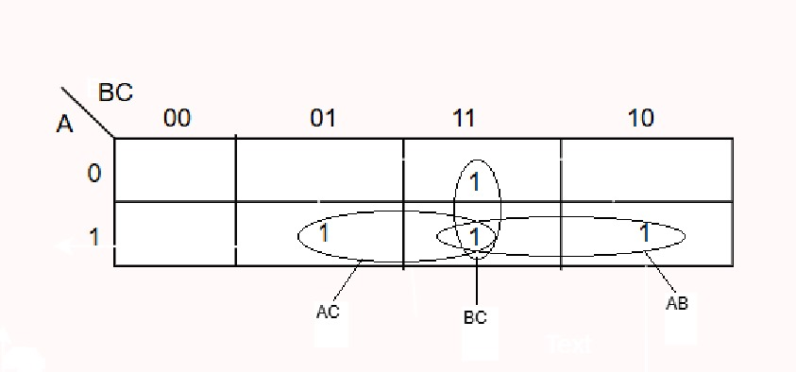
Boolean Expression for F:
F = AC+BC+AB

3.Circuit Diagram:
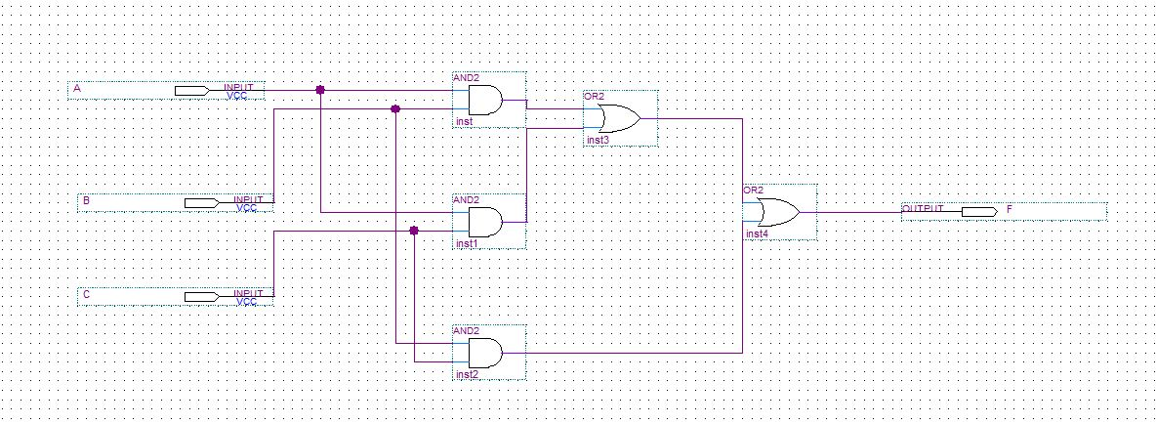
Simulation Result:
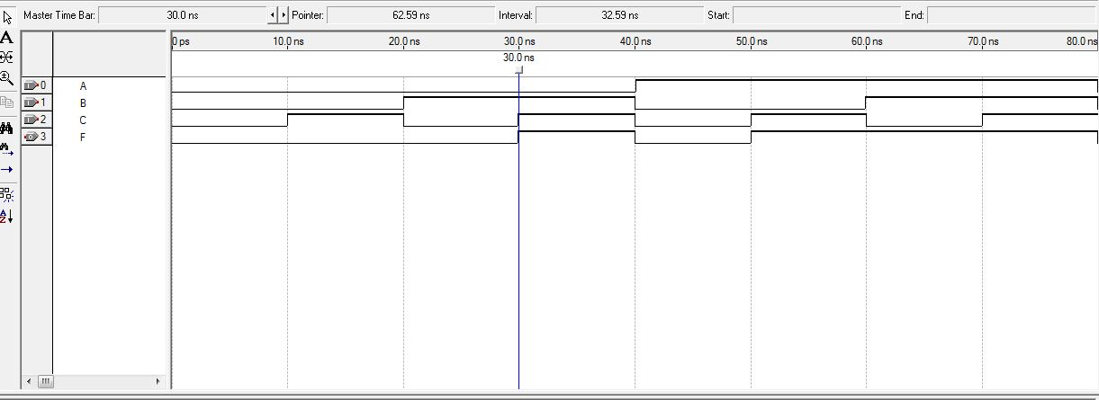

4.Behavioral Verilog Code
Procedural Model:
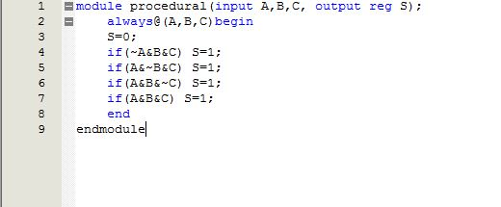
Simulation Result:
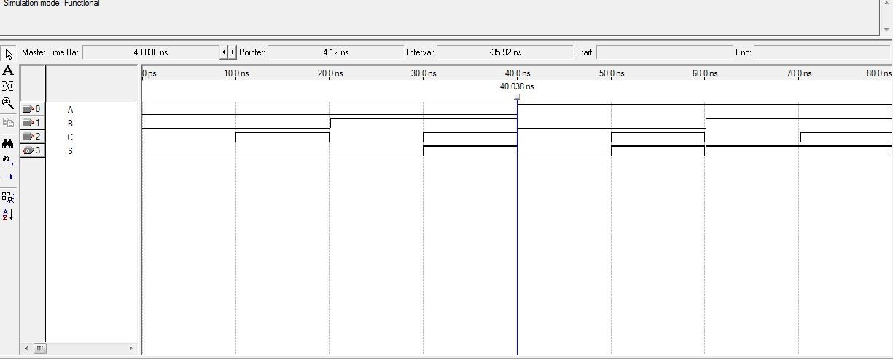
Continuous assign Statement:
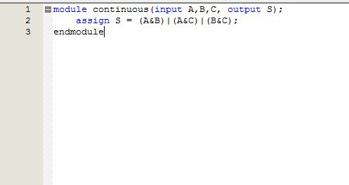
Simulation Result:
